DEEP LEARNING
Assignment-2
Name: Subhapreet Patro
Roll No.: 2211CS010547
Section: I
Q1) Create a simple computational graph for the equation: Y=(a+b)∗(b−c) with explanation.
A)
To create a computational graph for the equation:
Y = (a + b) × (b − c)
We break it down into smaller steps and represent each operation as a node in the graph. This is useful in deep learning and backpropagation because it lets us visualize and compute intermediate results and gradients efficiently.

Let’s define intermediate variables:
- t1 = a + b
- t2 = b − c
- Y = t1 × t2

Variables and Operations:
- Inputs: a, b, c
- Intermediate Nodes: t1, t2
- Output: Y

Computational Graph:
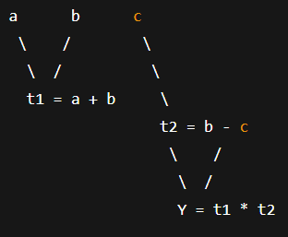

Explanation of Each Node:
Node | Operation | Description
t1 | a + b | Adds inputs a and b
t2 | b − c | Subtracts c from b
Y | t1 × t2 | Multiplies the results of t1 and t2

Example with Values:
Let’s take:
- a = 2, b = 3, c = 1
Compute step-by-step:
- t1 = a + b = 2 + 3 = 5
- t2 = b − c = 3 − 1 = 2
- Y = t1 × t2 = 5 × 2 = 10

Final Output:
Y = (a + b) × (b − c) is represented as a graph with:
- Input nodes: a, b, c
- Operation nodes: addition, subtraction, multiplication
- Output node: Y
This structure is useful for:
- Forward computation (to calculate the value of Y)
- Backward computation (to calculate gradients with respect to a, b, c in machine learning)

Q2) Explain Perceptron Activation Functions: Sigmoid
A)
What is a Perceptron?
A perceptron is the basic unit of a neural network. It takes multiple inputs, applies weights to them, sums them up, and then passes the result through an activation function to produce an output.

Activation Functions
Activation functions introduce non-linearity into a neural network. Without them, the entire network would behave like a linear model, no matter how many layers it has.
The Sigmoid function is one of the most commonly used activation functions—especially in early neural networks and binary classification problems.

Sigmoid Activation Function
➤ Mathematical Formula:
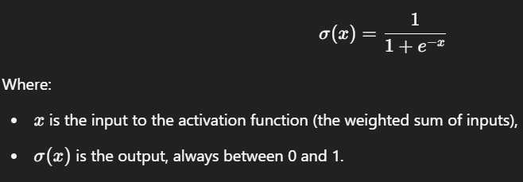
Sigmoid Graph
- The output of sigmoid smoothly ranges from 0 to 1.
- It's S-shaped (also called a logistic curve).
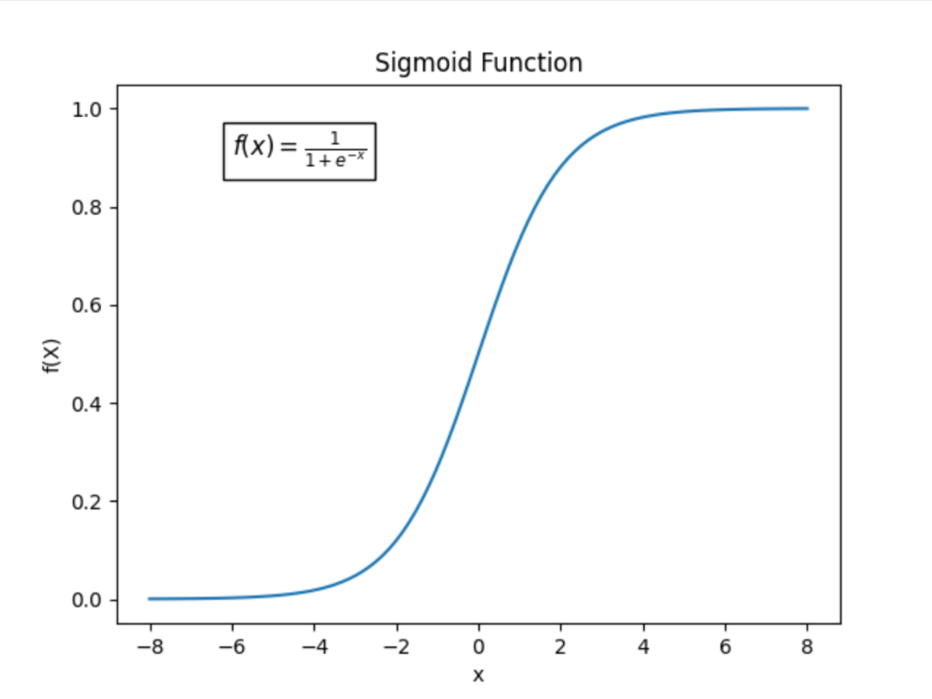
x (input) | sigmoid(x)
-∞ | ~0
0 | 0.5
+∞ | ~1

Sigmoid in a Perceptron
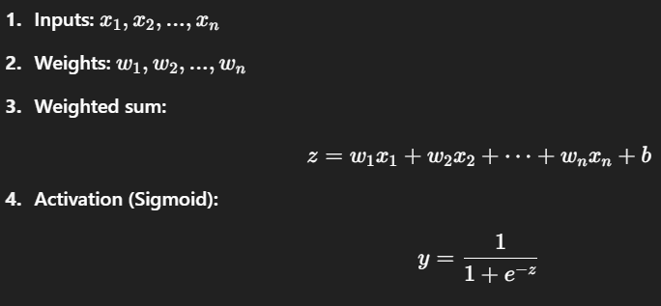
Properties of Sigmoid
Property | Description
Range | (0, 1)
Non-linear | Helps neural networks learn complex patterns
Differentiable | Smooth and has a well-defined derivative
Derivative
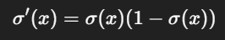
Used in backpropagation |
| Centered | Not zero-centered, which may slow convergence |
Advantages
- Useful for binary classification (acts like probability).
- Smooth gradient — helps in gradient-based optimization.
- Output is always bounded between 0 and 1.
Disadvantages
Issue | Explanation
Vanishing gradient | For very high or low input values, gradients become very small → slow learning
Not zero-centered | Can lead to zigzagging gradients during optimization
Computationally expensive | Exponential function e−xe^{-x} is more expensive than ReLU

Use Cases
- Output layer in binary classification models
- Logistic regression
- Earlier neural network models

Q3) Build a Simple model for predicting output of the XOR logic gate using TensorFlow.
A)
What is XOR?
The XOR (Exclusive OR) logic gate has the following behavior:
Input A | Input B | Output (A ⊕ B)
0 | 0 | 0
0 | 1 | 1
1 | 0 | 1
1 | 1 | 0
The XOR function is not linearly separable, so we need a neural network with at least one hidden layer to solve it.

Steps to Build the XOR Model Using TensorFlow
We'll use TensorFlow and Keras to build a small neural network.
1. Install Required Libraries
If you haven’t already:
pip install tensorflow

2. Import TensorFlow
import tensorflow as tf
import numpy as np

3. Prepare the Data
# Input features
X = np.array([
[0, 0],
[0, 1],
[1, 0],
[1, 1]
], dtype=np.float32)

# XOR outputs
y = np.array([
[0],
[1],
[1],
[0]
], dtype=np.float32)

4. Build the Model
model = tf.keras.Sequential([
tf.keras.layers.Dense(4, input_shape=(2,), activation='sigmoid'),
tf.keras.layers.Dense(1, activation='sigmoid')
])
Explanation:
- Input layer: Takes 2 inputs (A and B)
- Hidden layer: 4 neurons with sigmoid activation
- Output layer: 1 neuron with sigmoid activation (for binary classification)

5. Compile the Model
model.compile(
optimizer='adam',
loss='binary_crossentropy',
metrics=['accuracy']
)

6. Train the Model
history = model.fit(X, y, epochs=1000, verbose=0)

7. Evaluate the Model
loss, accuracy = model.evaluate(X, y)
print(f"Loss: {loss:.4f}, Accuracy: {accuracy:.4f}")

8. Make Predictions
predictions = model.predict(X)
predicted_labels = (predictions > 0.5).astype(int)

print("Predictions:")
for i in range(len(X)):
print(f"Input: {X[i]} → Predicted: {predicted_labels[i][0]}, Actual: {int(y[i][0])}")

Expected Output:
Input: [0. 0.] → Predicted: 0, Actual: 0
Input: [0. 1.] → Predicted: 1, Actual: 1
Input: [1. 0.] → Predicted: 1, Actual: 1
Input: [1. 1.] → Predicted: 0, Actual: 0

Q4) What is a Perceptron & explain its components with a diagram?
A)
What is a Perceptron?
A Perceptron is the simplest type of artificial neural network, introduced by Frank Rosenblatt in 1958. It models how a single neuron in the brain might process inputs and produce an output. It’s primarily used for binary classification (classifying input into one of two categories).

Definition
A perceptron takes multiple inputs, applies corresponding weights, adds a bias, and passes the result through an activation function to produce a binary output (usually 0 or 1).

Mathematical Representation
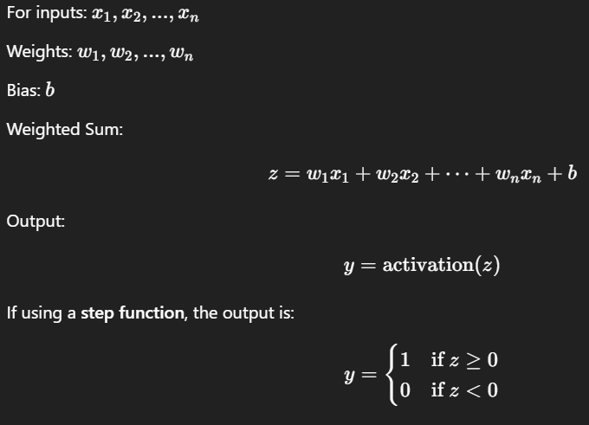

Components of a Perceptron
Component | Description
Inputs (x₁, x₂, ..., xₙ) | Numerical features fed into the model
Weights (w₁, w₂, ..., wₙ) | Coefficients that determine the importance of each input
Bias (b) | A constant added to the weighted sum for shifting the activation
Summation Function | Adds all weighted inputs and the bias
Activation Function | Converts the sum into a binary output (like step, sigmoid, ReLU, etc.)
Output (y) | Final prediction (0 or 1 for binary classification)

Working of a Perceptron – Step by Step
- Receive inputs x1,x2,...,xnx_1, x_2, ..., x_n
- Multiply each input by its weight w1,w2,...,wnw_1, w_2, ..., w_n
- Add the results + bias → total sum zz
- Pass zz through an activation function
- Output the final result yy

Perceptron Diagram
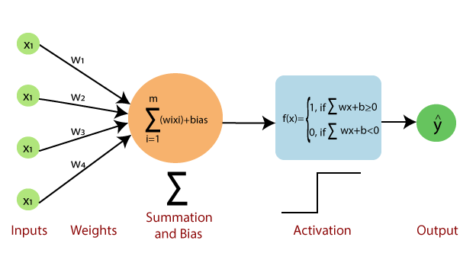
Example
Let’s say:
- x1=2, x2=3
- w1=0.4, w2=0.7
- b=−1
Then,
z=(2×0.4)+(3×0.7)+(−1)=0.8+2.1−1=1.9
If using a step function:
y=1(since 1.9>0)

Learning in a Perceptron
During training:
- The perceptron updates its weights and bias using gradient descent and an error term to minimize incorrect predictions.

Limitations of Single-Layer Perceptron
Limitation | Explanation
Only linearly separable data | Cannot solve problems like XOR
No hidden layers | Cannot learn complex patterns
To overcome this, we use multi-layer perceptrons (MLPs), which are the building blocks of deep neural networks.

